Working with Entity Framework

Author | Marcos Lara
When | 10-May-2024
Why | Provide a step-by-step guide to implement Entity Framework using .NET9
Version | 1.0

Example with Sqlite database:

Note: The same steps described in this document can be used with any database supported by the Microsoft Entity Framework.
Note: You can jump directly to the Summary and follow the sequence.

Create a minimal web Api project with dotnet.
>cd Projects
Create the solution.
>mkdir slnGym (Solution for a project Gym, may contain multiple projects)
>cd slnGym
>dotnet new solution (This will create a solution file named slnGym.sln)
>dotnet new webapi -n bckGym (this will create a folder bckGym and inside it the whole webapi dotnet minimal API).
>dotnet sln slnGym.sln add bckGym \bckGym csproj (add your project to the solution)
>cd bckGym

Add to your project the NuGet packages:
>dotnet add package Microsoft.EntityFrameworkCore.Sqlite
>dotnet add package Microsoft.EntityFrameworkCore.Design
Install this once for all your projects:
>dotnet tool install --global dotnet-ef

Prepare your tables:
In this example, I will be creating three tables:
Customer:
To store the data of the gym's customers.
Exercise:
To store the list of possible exercises.
CustomerGym:
To establish the relationship between Customers and their Exercises. The relationship type is One Customer to many Exercises, or simply One-to-Many.
Create a folder named 'Entities' and create your table class, each in its file, for example:
>mkdir Entities
>cd Entities
>echo > Customer.cs
>echo > Exerecise.cs
>echo > CustomerGym.cs
File: Entities\Customer.cs
namespace bckGym.Entities;
public class Customer{
public int CustomerId {get; set;}
public required string Name {get; set;}
public required string Weight {get; set;}
public required string Height {get; set;}
public required string Email {get; set;}
public DateOnly BirthDate {get; set;}
public DateTime Started {get; set;}
}

File: Entities\CustomerGym.cs
namespace bckGym.Entities;

public class CustomerGym
{
public int CustomerId { get; set; }
public int ExerciseId { get; set; }
// Navigation properties
public Customer? Customer { get; set; }
public Exercise? Exercise { get; set; }
}

File: Entities\Exercise.cs
namespace bckGym.Entities;

public class Exercise
{
public int ExerciseId { get; set; }
public required string? Name { get; set; }
public required string Category { get; set; }
public required string SubCategory { get; set; }
public required string MuscleFocus { get; set; }
public required string? Description { get; set; }
public int Duration { get; set; } //INTEGER CHECK(duration > 0),
//TEXT CHECK(difficulty IN ('easy', 'medium', 'hard')),
public required string Difficulty { get; set; }
//TIMESTAMP DEFAULT CURRENT_TIMESTAMP
public DateTime CreatedAt { get; set; }
}

Create a folder in your project named Data (can be any name)
Inside this folder, create a class DbContext: Example:
File: Data\GymDbContext.cs
using Microsoft.EntityFrameworkCore;
namespace bckGym.Data;
namespace bckGym.Entities;

public class GymDbContext(DbContextOptions<GymDbContext> options) : DbContext(options)
{
public DbSet<Customer> Customers => Set<Customer>();
public DbSet<Exercise> Exercises => Set<Exercise>();
public DbSet<CustomerGym> CustomerGyms => Set<CustomerGym>();

protected override void OnModelCreating(ModelBuilder modelBuilder)
{
modelBuilder.Entity<CustomerGym>()
.HasKey(c => new { c.CustomerId, c.ExerciseId });
// Composite primary key ensures uniqueness

modelBuilder.Entity<Exercise>()
.ToTable(tb =>
{
tb.HasCheckConstraint("CK_Exercise_Duration", "Duration > 0");
// Ensure duration is positive
tb.HasCheckConstraint("CK_Exercise_Difficulty",
"Difficulty IN ('easy', 'medium', 'hard')");
// Restrict values
});
}
}

Notes:
The first line adds the Entity Framework
The class name (GymDbContext) is repeated as we want to inject it into the DbContext
Each table, such as Customers, Exercises, and CustomerGyms, must be declared here.
The method OnModelCreating is mandatory for adding the key CustomerID.

Create your DataExtension class. This is created to handle the automatic Database update when the application starts.

File: Data\DataExtensions.cs

using Microsoft.EntityFrameworkCore;

namespace bckGym.Data;

public static class DataExtensions
{
public static void MigrateDb(this WebApplication app)
{
// using release the scope when the block finishes
using var scope = app.Services.CreateScope();
var dbContext = scope.ServiceProvider.GetRequiredService<GymDbContext>();
dbContext.Database.Migrate();
}
}

Register this new service for the component injection into the Program.cs

Add this first line, so the Program.cs knows where to find your GymDbContext.

using bckGym.Data;

//You can create the connectionString in appsettings.json
var connString = "Data Source=GymDb.db";

builder.Services.AddSqlite<GymDbContext>(connString);

Alternatively, you can set up the ‘stringConnection’ in your appsettings.json

Run the migration

>dotnet ef migrations add InitialCreate --output-dir Data\Migrations

Note: The InitialCreate can be any name.
This command will create a folder named 'Migrations' inside the 'Data' folder to store the SQL scripts for migration.

You can consult our migration by running this command:

>dotnet ef migrations list

Note: You see that your ‘Migration’ is pending

You can consult the scripts created using this command:

>dotnet ef migrations script

Execute the migration code.

>dotnet ef database update

Note: This command executes the SQL scripts created during the migration process.
You will note that beyond your tables, the EF created another table to control the migrations

Note: This will create the database and all objects specified in the previous automatically generated code.
This will show something like this:
Example of execution:

>dotnet ef database update

Load VSCode

>code .

Note: A file named GymDB.db is created in your project; this is our database file. Be careful not to send it to your Git repository.

Install the VS Code extension ‘SQLite’, which enables us to view the database and its objects.

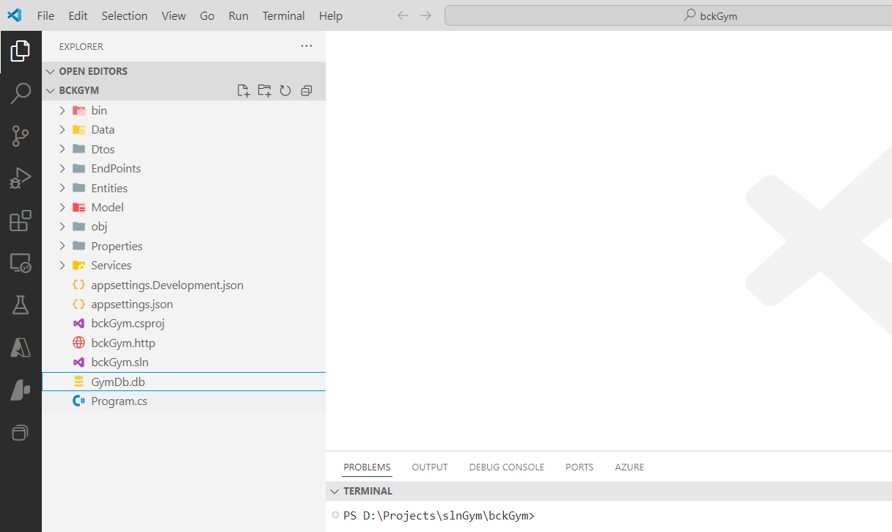

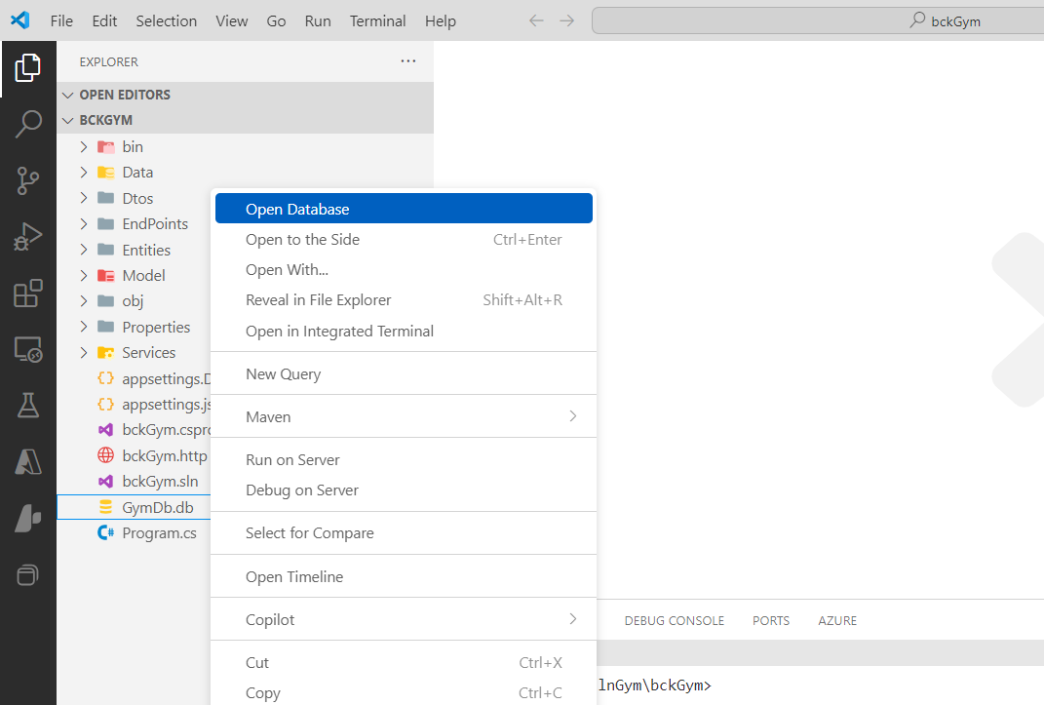

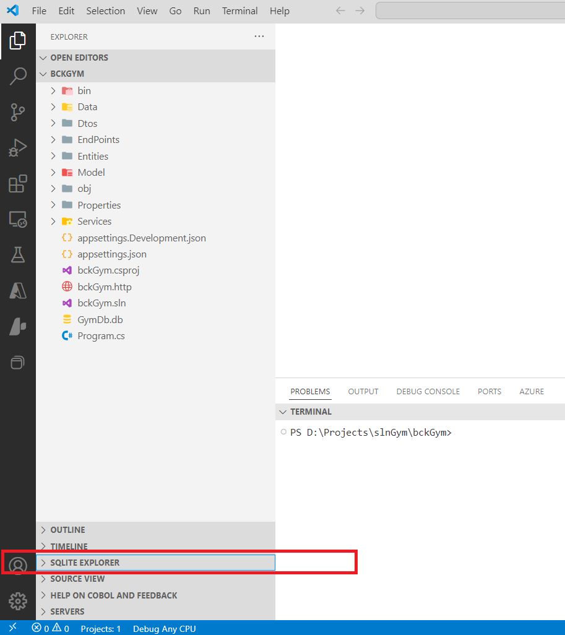

Remove unnecessary information from your logs:

Located in your application console log, the workspace where you want to see only critical warnings or errors:
For example, we are going to remove all ‘info’ related to the highlighted yellow line below.
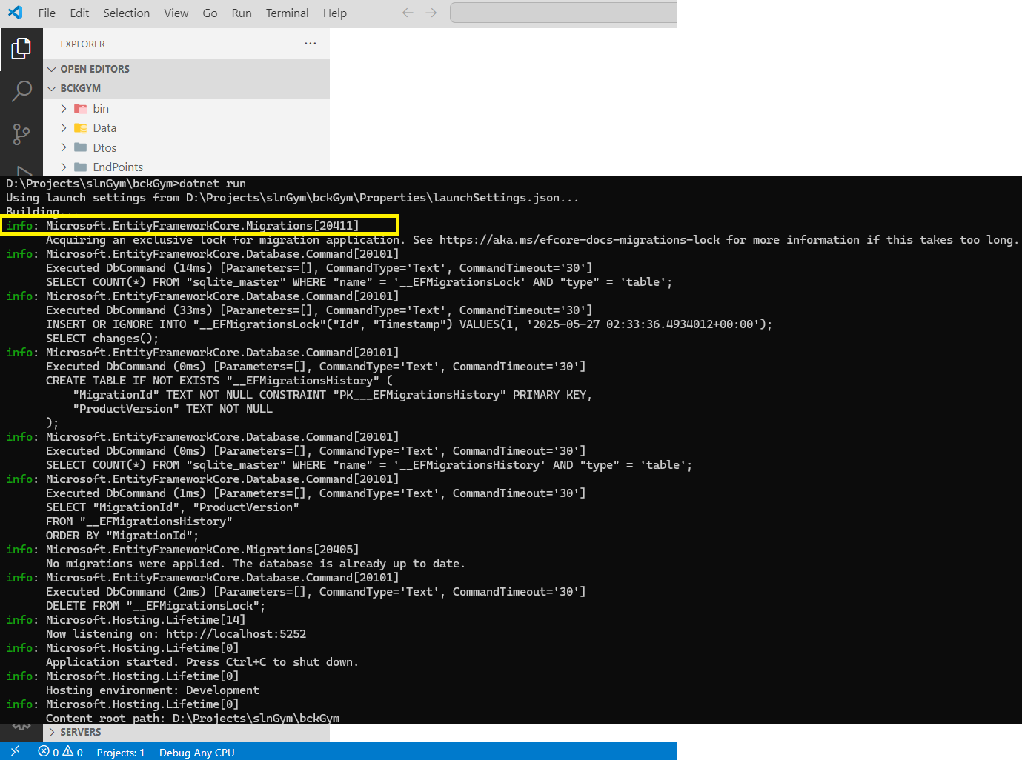

Then modify your appsettings, adding the kind of severity of messages you want to see for that particular entry:

{
"Logging": {
"LogLevel": {
"Default": "Information",
"Microsoft.AspNetCore": "Warning",
"Microsoft.EntityFrameworkCore.Migrations": "Warning",
"Microsoft.EntityFrameworkCore.Database.Command": "Warning"
}
},
"ConnectionStrings":{
"GymDbConnection": "Data Source=GymDb.db"
},
"AllowedHosts": "*"
}

Run your app.
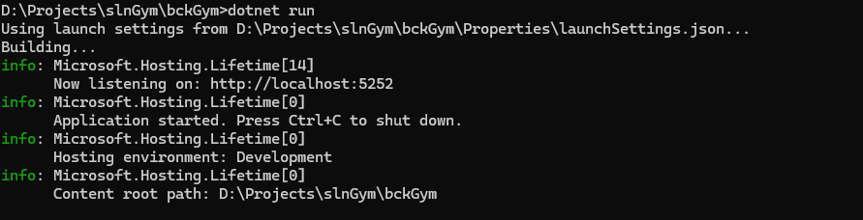

Optional stuffs
Populate some database tables automatically:
Modify your DbContext class by adding the data you want to add to the database:

Example:
modelBuilder.Entity<Customer>().HasData(

new
{
CustomerID = 123456,
Name = "Rosemiro Lateral Esquerdo",
Weight = "65kg",
Height = "1.75",
Email = "rosemiroesquerdo@palmeiras.com",
BirthDate = DateOnly.FromDateTime(new DateTime(1974, 05, 19)),
Started = DateOnly.FromDateTime(new DateTime(1993, 5, 22))
},
new
{
CustomerID = 123457,
Name = "Cafu Lateral Direito",
Weight = "61kg",
Height = "1.81m",
Email = "Cafudireito@palmeiras.com",
BirthDate = DateOnly.FromDateTime(new DateTime(1976, 11, 28)),
Started = DateOnly.FromDateTime(new DateTime(1993, 5, 22))
},
new
{
CustomerID = 123458,
Name = "Rivaldo Meio Campo",
Weight = "71kg",
Height = "1.84m",
Email = "Rivaldomeiocampo@palmeiras.com",
BirthDate = DateOnly.FromDateTime(new DateTime(1971, 12, 12)),
Started = DateOnly.FromDateTime(new DateTime(1993, 5, 22))
});

Then, rerun the migration, but change the Migration name:
>dotnet ef migrations add SeedTables --output-dir Data\Migrations

>dotnet run

Summary:

- Create your project
- Install the NuGet packages
- Install the EF application
- Create your Entities class, (Class tables)
- Create the DbContext and DataExtensions classes
- Modify your Program.cs
- Create the DbContext, (Define your class tables that will be created by EF)
- Run the EF migration
- Run the EF update

>cd Projects
>dotnet new webapi -n bckGym
>cd bckGym
>dotnet add package Microsoft.EntityFrameworkCore.Sqlite
>dotnet add package Microsoft.EntityFrameworkCore.Design
>dotnet tool install --global dotnet-ef
>mkdir Entities
>cd Entities
>copy con Customer.cs
namespace bckGym.Entities;
public class Customer{
public int CustomerId {get; set;}
public required string Name {get; set;}
public required string Weight {get; set;}
public required string Height {get; set;}
public required string Email {get; set;}
public DateOnly BirthDate {get; set;}
public DateTime Started {get; set;}
}^Z

>coy con Exercise.cs
namespace bckGym.Entities;

public class Exercise
{
public int ExerciseId { get; set; }
public required string? Name { get; set; }
public required string Category { get; set; }
public required string SubCategory { get; set; }
public required string MuscleFocus { get; set; }
public required string? Description { get; set; }
public int Duration { get; set; } //INTEGER CHECK(duration > 0),
//TEXT CHECK(difficulty IN ('easy', 'medium', 'hard')),
public required string Difficulty { get; set; }
//TIMESTAMP DEFAULT CURRENT_TIMESTAMP
public DateTime CreatedAt { get; set; }
}^Z

>copy con CustomerGym.cs
namespace bckGym.Entities;

public class CustomerGym
{
public int CustomerId { get; set; }
public int ExerciseId { get; set; }
// Navigation properties
public Customer? Customer { get; set; }
public Exercise? Exercise { get; set; }
}

>mkdir Data
>cd Data
>copy con DataExtensions.cs
using Microsoft.EntityFrameworkCore;
namespace bckGym.Data;

public static class DataExtensions
{
public static void MigrateDb(this WebApplication app)
{
// using release, the scope when the block finishes
using var scope = app.Services.CreateScope();
var dbContext = scope.ServiceProvider.GetRequiredService<GymDbContext>();
dbContext.Database.Migrate();
}
}
>copy con GymDbContext.cs

using Microsoft.EntityFrameworkCore;
using bckGym.Entities;

namespace bckGym.Data;

public class GymDbContext(DbContextOptions<GymDbContext> options) : DbContext(options)
{
public DbSet<Customer> Customers => Set<Customer>();
public DbSet<Exercise> Exercises => Set<Exercise>();
public DbSet<CustomerGym> CustomerGyms => Set<CustomerGym>();

protected override void OnModelCreating(ModelBuilder modelBuilder)
{
// Composite primary key ensures uniqueness
modelBuilder.Entity<CustomerGym>()
.HasKey(c => new { c.CustomerId, c.ExerciseId });

modelBuilder.Entity<Exercise>()
.ToTable(tb =>
{
// Ensure duration is positive
tb.HasCheckConstraint("CK_Exercise_Duration", "Duration > 0");
// Restrict values
tb.HasCheckConstraint("CK_Exercise_Difficulty",
"Difficulty IN ('easy', 'medium', 'hard')");
});
}
}

>cd ..
>dotnet ef migrations add InitialCreate --output-dir Data\Migrations
Build started...
Build succeeded.
Done. To undo this action, use 'ef migrations remove'

>dotnet ef migrations list
Build started...
Build succeeded.
20250528215857_InitialCreate (Pending)

>dotnet ef migrations script
Build started...
Build succeeded.
CREATE TABLE IF NOT EXISTS "__EFMigrationsHistory" (
"MigrationId" TEXT NOT NULL CONSTRAINT "PK___EFMigrationsHistory" PRIMARY KEY,
"ProductVersion" TEXT NOT NULL
);

BEGIN TRANSACTION;
CREATE TABLE "Customers" (
"CustomerId" INTEGER NOT NULL CONSTRAINT "PK_Customers" PRIMARY KEY AUTOINCREMENT,
"Name" TEXT NOT NULL,
"Weight" TEXT NOT NULL,
"Height" TEXT NOT NULL,
"Email" TEXT NOT NULL,
"BirthDate" TEXT NOT NULL,
"Started" TEXT NOT NULL
);

CREATE TABLE "Exercises" (
"ExerciseId" INTEGER NOT NULL CONSTRAINT "PK_Exercises" PRIMARY KEY AUTOINCREMENT,
"Name" TEXT NULL,
"Category" TEXT NOT NULL,
"SubCategory" TEXT NOT NULL,
"MuscleFocus" TEXT NOT NULL,
"Description" TEXT NULL,
"Duration" INTEGER NOT NULL,
"Difficulty" TEXT NOT NULL,
"CreatedAt" TEXT NOT NULL,
CONSTRAINT "CK_Exercise_Difficulty" CHECK (Difficulty IN ('easy', 'medium', 'hard')),
CONSTRAINT "CK_Exercise_Duration" CHECK (Duration > 0)
);

CREATE TABLE "CustomerGyms" (
"CustomerId" INTEGER NOT NULL,
"ExerciseId" INTEGER NOT NULL,
CONSTRAINT "PK_CustomerGyms" PRIMARY KEY ("CustomerId", "ExerciseId"),
CONSTRAINT "FK_CustomerGyms_Customers_CustomerId" FOREIGN KEY ("CustomerId") REFERENCES "Customers" ("CustomerId") ON DELETE CASCADE,
CONSTRAINT "FK_CustomerGyms_Exercises_ExerciseId" FOREIGN KEY ("ExerciseId") REFERENCES "Exercises" ("ExerciseId") ON DELETE CASCADE
);

CREATE INDEX "IX_CustomerGyms_ExerciseId" ON "CustomerGyms" ("ExerciseId");

INSERT INTO "__EFMigrationsHistory" ("MigrationId", "ProductVersion")
VALUES ('20250528215857_InitialCreate', '9.0.5');

COMMIT;

>dotnet ef database update
Build started...
Build succeeded.
info: Microsoft.EntityFrameworkCore.Database.Command[20101]
Executed DbCommand (42ms) [Parameters=[], CommandType='Text', CommandTimeout='30']
PRAGMA journal_mode = 'wal';
info: Microsoft.EntityFrameworkCore.Migrations[20411]
Acquiring an exclusive lock for migration application. See https://aka.ms/efcore-docs-migrations-lock for more information if this takes too long.
Acquiring an exclusive lock for migration application. See https://aka.ms/efcore-docs-migrations-lock for more information if this takes too long.
info: Microsoft.EntityFrameworkCore.Database.Command[20101]
Executed DbCommand (5ms) [Parameters=[], CommandType='Text', CommandTimeout='30']
SELECT COUNT(*) FROM "sqlite_master" WHERE "name" = '__EFMigrationsLock' AND "type" = 'table';
info: Microsoft.EntityFrameworkCore.Database.Command[20101]
Executed DbCommand (4ms) [Parameters=[], CommandType='Text', CommandTimeout='30']
CREATE TABLE IF NOT EXISTS "__EFMigrationsLock" (
"Id" INTEGER NOT NULL CONSTRAINT "PK___EFMigrationsLock" PRIMARY KEY,
"Timestamp" TEXT NOT NULL
);
info: Microsoft.EntityFrameworkCore.Database.Command[20101]
Executed DbCommand (1ms) [Parameters=[], CommandType='Text', CommandTimeout='30']
INSERT OR IGNORE INTO "__EFMigrationsLock"("Id", "Timestamp") VALUES(1, '2025-05-28 22:02:09.8748321+00:00');
SELECT changes();
info: Microsoft.EntityFrameworkCore.Database.Command[20101]
Executed DbCommand (0ms) [Parameters=[], CommandType='Text', CommandTimeout='30']
CREATE TABLE IF NOT EXISTS "__EFMigrationsHistory" (
"MigrationId" TEXT NOT NULL CONSTRAINT "PK___EFMigrationsHistory" PRIMARY KEY,
"ProductVersion" TEXT NOT NULL
);
info: Microsoft.EntityFrameworkCore.Database.Command[20101]
Executed DbCommand (0ms) [Parameters=[], CommandType='Text', CommandTimeout='30']
SELECT COUNT(*) FROM "sqlite_master" WHERE "name" = '__EFMigrationsHistory' AND "type" = 'table';
info: Microsoft.EntityFrameworkCore.Database.Command[20101]
Executed DbCommand (1ms) [Parameters=[], CommandType='Text', CommandTimeout='30']
SELECT "MigrationId", "ProductVersion"
FROM "__EFMigrationsHistory"
ORDER BY "MigrationId";
info: Microsoft.EntityFrameworkCore.Migrations[20402]
Applying migration '20250528215857_InitialCreate'.
Applying migration '20250528215857_InitialCreate'.
info: Microsoft.EntityFrameworkCore.Database.Command[20101]
Executed DbCommand (0ms) [Parameters=[], CommandType='Text', CommandTimeout='30']
CREATE TABLE "Customers" (
"CustomerId" INTEGER NOT NULL CONSTRAINT "PK_Customers" PRIMARY KEY AUTOINCREMENT,
"Name" TEXT NOT NULL,
"Weight" TEXT NOT NULL,
"Height" TEXT NOT NULL,
"Email" TEXT NOT NULL,
"BirthDate" TEXT NOT NULL,
"Started" TEXT NOT NULL
);
info: Microsoft.EntityFrameworkCore.Database.Command[20101]
Executed DbCommand (0ms) [Parameters=[], CommandType='Text', CommandTimeout='30']
CREATE TABLE "Exercises" (
"ExerciseId" INTEGER NOT NULL CONSTRAINT "PK_Exercises" PRIMARY KEY AUTOINCREMENT,
"Name" TEXT NULL,
"Category" TEXT NOT NULL,
"SubCategory" TEXT NOT NULL,
"MuscleFocus" TEXT NOT NULL,
"Description" TEXT NULL,
"Duration" INTEGER NOT NULL,
"Difficulty" TEXT NOT NULL,
"CreatedAt" TEXT NOT NULL,
CONSTRAINT "CK_Exercise_Difficulty" CHECK (Difficulty IN ('easy', 'medium', 'hard')),
CONSTRAINT "CK_Exercise_Duration" CHECK (Duration > 0)
);
info: Microsoft.EntityFrameworkCore.Database.Command[20101]
Executed DbCommand (0ms) [Parameters=[], CommandType='Text', CommandTimeout='30']
CREATE TABLE "CustomerGyms" (
"CustomerId" INTEGER NOT NULL,
"ExerciseId" INTEGER NOT NULL,
CONSTRAINT "PK_CustomerGyms" PRIMARY KEY ("CustomerId", "ExerciseId"),
CONSTRAINT "FK_CustomerGyms_Customers_CustomerId" FOREIGN KEY ("CustomerId") REFERENCES "Customers" ("CustomerId") ON DELETE CASCADE,
CONSTRAINT "FK_CustomerGyms_Exercises_ExerciseId" FOREIGN KEY ("ExerciseId") REFERENCES "Exercises" ("ExerciseId") ON DELETE CASCADE
);
info: Microsoft.EntityFrameworkCore.Database.Command[20101]
Executed DbCommand (0ms) [Parameters=[], CommandType='Text', CommandTimeout='30']
CREATE INDEX "IX_CustomerGyms_ExerciseId" ON "CustomerGyms" ("ExerciseId");
info: Microsoft.EntityFrameworkCore.Database.Command[20101]
Executed DbCommand (0ms) [Parameters=[], CommandType='Text', CommandTimeout='30']
INSERT INTO "__EFMigrationsHistory" ("MigrationId", "ProductVersion")
VALUES ('20250528215857_InitialCreate', '9.0.5');
info: Microsoft.EntityFrameworkCore.Database.Command[20101]
Executed DbCommand (1ms) [Parameters=[], CommandType='Text', CommandTimeout='30']
DELETE FROM "__EFMigrationsLock";
Done.

>dir
Volume in drive D is New Volume
Volume Serial Number is 4A13-1E33

Directory of D:\Projects\slnGym\bckGym

29/05/2025 10:02 am <DIR> .
29/05/2025 09:22 am <DIR> ..
29/05/2025 09:22 am 127 appsettings.Development.json
29/05/2025 09:22 am 151 appsettings.json
29/05/2025 09:25 am 679 bckGym.csproj
29/05/2025 09:22 am 125 bckGym.http
29/05/2025 09:32 am <DIR> bin
29/05/2025 09:58 am <DIR> Data
29/05/2025 09:28 am <DIR> Entities
29/05/2025 10:02 am 40,960 GymDb.db
29/05/2025 09:32 am <DIR> obj
29/05/2025 09:49 am 1,264 Program.cs
29/05/2025 09:22 am <DIR> Properties
6 File(s) 43,306 bytes
7 Dir(s) 659,577,188,352 bytes free

>code .

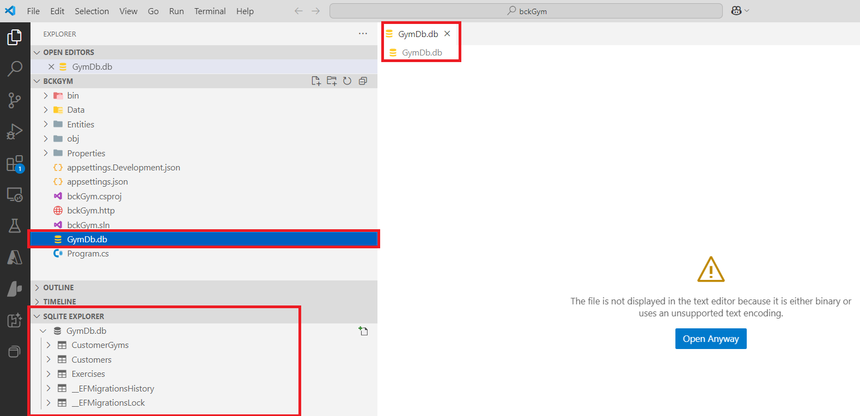

Some helpful commands:
To clean up and start from scratch
>dotnet ef database drop --force

>dotnet ef migrations remove

This creates the migration scripts:

>dotnet ef migrations add InitialCreate --output-dir Data\Migrations

Note: You need to run this command for every change you make in the entity classes and give it a different name. For example, if you add a new field to a particular table, you can run this command again, but instead of InitialCreate, you should name it differently, for example: You can use the name, AddingFieldNameToTableCustomer, indicating the kind of change you made in your class Customer.cs.
If you wish to return to the status that was in place before you added this field, you can simply remove this migration by running the command:

>dotnet ef migrations remove

This will remove the last command you ran with the “migrations” command. Once you remove the migration, run the ‘update’ command.

List your migrations:

>dotnet ef migrations list

List your scripts. At this point, only the Migration tables were created:

>dotnet ef migrations script
Build started...
Build succeeded.
CREATE TABLE IF NOT EXISTS "__EFMigrationsHistory" (
"MigrationId" TEXT NOT NULL CONSTRAINT "PK___EFMigrationsHistory" PRIMARY KEY,
"ProductVersion" TEXT NOT NULL
);

BEGIN TRANSACTION;
INSERT INTO "__EFMigrationsHistory" ("MigrationId", "ProductVersion")
VALUES ('20250528024445_InitialCreate', '9.0.5');

COMMIT;

This runs the scripts created with the previous command:

>dotnet ef database update
Build started...
Build succeeded.
info: Microsoft.EntityFrameworkCore.Migrations[20411]
Acquiring an exclusive lock for migration application. See https://aka.ms/efcore-docs-migrations-lock for more information if this takes too long.
Acquiring an exclusive lock for migration application. See https://aka.ms/efcore-docs-migrations-lock for more information if this takes too long.
info: Microsoft.EntityFrameworkCore.Migrations[20402]
Applying migration '20250528024445_InitialCreate'.
Applying migration '20250528024445_InitialCreate'.
Done.

Recheck your scripts:

>dotnet ef migrations script

